

**Santa Clara Westside Little League**

League ID: 4054412

ASAP: A Safety Awareness Program

2025 Safety & Security Plan

[2025 Safety Plan](https://docs.google.com/document/d/1i70Yu3fczmYmk-CrFEKupzOaUixpCkWw/edit)

Safety Officer: Anthony Pascoal

[safety.westside@gmail.com](mailto:safety.westside@gmail.com)

(408) 644-5397

Contents

Introduction 5

1 Publication of Safety & Emergency Information 6

1.1 Publication 6

1.2 Emergency Information 6

1.3 Emergency Numbers - To be Posted at Fields 6

1.4 Santa Clara Westside LL Board Contact Information 7

2 Safety Roles & Responsibilities 8

2.1 Safety Officer 8

2.2 Board President 8

2.3 Equipment Manager 8

2.4 Fields Maintenance Director 9

2.5 Managers/Coaches 9

2.6 Umpires 11

2.7 Parents 11

2.8 Players 11

3 Emergency & Injury Notifications 12

3.1 Emergency Notification Procedures 12

3.2 What to do if a Player is Injured 12

3.2.1 First Aid Guidance 13

3.2.2 Cardiac Arrest – Immediately Call 911 13

3.2.3 Concussions & Head Injuries 13

3.2.4 Heat Illness 13

3.2.5 Dental Injuries 14

3.2.6 Bloodborne Pathogens 14

3.2.7 COVID – 19 14

3.3 Injury Reporting 14

3.3.1 What to Report? 15

3.3.2 Incident/Injury Tracking Report 15

3.3.3 Accident Claim Form 15

3.3.4 Return to Play 16

4 Player Evaluations and Team Placement Safety 17

4.1 2025 Little League Age Chart 17

4.2 Guidelines for Division Placement 18

4.3 Special Physical Conditions 18

5 Volunteer Screening & Compliance 19

5.1 Little League Volunteer Application & Background Check 19

5.1.1 Background check (JDP) process for volunteers 19

5.2 Fingerprint Background Check Requirement (LiveScan) 20

5.2.1 Child Protection Program and Mandated Reporters 20

5.2.2 LiveScan Process for Volunteers 20

5.3 Mandated Notice of Background Check Process per California Law 21

6 Safety Training 22

6.1 Managers Meetings 22

6.2 CPR/AED/First Aid Training 22

6.3 Concussion Safety 23

6.4 Diamond Leadership Training 23

6.5 Abuse Awareness Training 23

6.6 District 44 Rules Clinic 24

6.7 Baseball Fundamentals 24

6.8 Umpire Training Clinic 24

6.9 Positive Coaching Alliance 25

6.10 Training Requirements Guide 25

6.11 Credentialing 25

6.12 Submitting Training Documentation 25

7 Fields & Facility Safety 26

7.1 Field & Facility Access 26

7.2 Field Inspections 26

7.3 Guidelines for the use of Batting Cages 26

7.4 Maintenance and Equipment Shed Safety 26

7.5 Concession Stand (Snack Shack) Safety 27

7.5.1 Concession Stand Inspection Checklist 27

7.5.2 Food Safety 27

7.5.3 Food Safety Certification 28

7.5.4 General Concession Stand Safety 28

7.5.5 Additional Concession Stand Safety Resources 29

8 Equipment & Player Safety 31

8.1 Equipment Inspection & Replacement 31

8.1.1 Required Equipment 31

8.1.2 Bats 31

8.2 Manager’s & Umpire’s Responsibilities 31

8.2.1 Prior to Each Practice 31

8.2.2 Prior to Each Game 31

8.2.3 During Each Game 32

8.2.4 Following Each Game 33

8.3 First Aid Kits 33

8.4 Automated External Defibrillator (AED) Machines 33

8.5 Fire Extinguishers 33

9 Inclement Weather & Environmental Factors 34

9.1 Rain 34

9.2 Lightning 35

9.3 Hot Weather 36

9.4 Air Quality Policy 36

9.5 Earthquake 37

10 Social Media Safety 38

10.1 Official Westside LL Website & Social Media Accounts 38

10.2 Social Media Community Guidelines 38

11 Code of Conduct 39

11.1 Preamble 39

11.2 Code of Conduct 39

12 Enforce little league rules & Regulations 41

13 Appendix 42

13.1 Quick Safety Checklist for Managers, Coaches & Umpires 42

13.1.1 Safe Playing Areas 42

13.1.2 Safe Equipment 42

13.1.3 Safe Procedures 42

13.2 Field Operations Plans 43

13.2.1 Steve Carli Park – 1045 Los Padres Ave, Santa Clara, Ca 95050 43

13.2.2 Earl R. Carmichael Park – 3445 Benton St., Santa Clara, Ca 95050 44

13.3 Fact Sheets 45

13.3.1 AHA Heart Attack Warning Signs 45

13.3.3 Heat Illness Fact Sheet 47

# Introduction

Santa Clara Westside Little League’s (“Westside LL or SCWLL”) priority is Safety First! The entire Westside LL community must work together to ensure that games, practices, and other events remain safe – and therefore fun – for all Westside LL players. This Safety Plan explains the necessary contributions from all participants including league officials, managers, coaches, parents, and players. It also provides all Westside LL’s safety rules and other information.

The purpose of the Westside LL Safety Plan is to communicate guidelines for increasing the safety of activities, equipment, instruction and facilities through education, compliance, and reporting. In support of this goal, Westside LL also commits itself to providing the necessary organizational structure and focus to develop, monitor, and enforce compliance with all aspects of this Safety Plan.

Little League International introduced A Safety Awareness Program (ASAP) in 1995 with the goal of re-emphasizing the position of the Safety Officer to create awareness through education and information, of the opportunities to provide a safer environment for all participants. This Safety Plan is also guided by Little League International’s [Child Protection Program](https://www.littleleague.org/player-safety/child-protection-program/).

The Safety Plan, which has been adopted by the Westside LL Board of Directors, outlines specific safety related policies and procedures of the League. All participants, volunteers, employees, spectators, and guests are bound by the guidelines set forth in this document.

This Safety Plan provides the guidelines and instructions for the safe operations of Westside LL. It will be made available to all managers, coaches, board members, umpires, and others involved in League activities via the Westside LL website. It will also be summarized at managers and parents’ meetings. We expect all League volunteers, players, and parents to abide by the Safety Plan and make safety a high priority in all League activities.

The Westside LL President and Safety Officer have primary responsibility for developing, implementing, and ensuring compliance with the Safety Plan. However, the entire Westside LL Board of Directors, elected League Officers, and Board Approved Managers and Coaches share in the responsibility to ensure awareness and compliance with the Safety Plan relative to their respective position or office.

Westside LL values contributions from the community. Please report any conditions observed that appear unsafe, or provide any suggestions for enhancing safety, to the Westside LL League Safety Officer at safety.westside@gmail.com

# Publication of Safety & Emergency Information

## Publication

As part of our ongoing efforts to maintain the safest environment possible, we want to make this Safety Plan readily available to all our managers/coaches, parents, umpires, players, and spectators. To this end we will:

* Maintain the most current version of this Safety Plan on our league [website](https://clubs.bluesombrero.com/Default.aspx?tabid=1231045)
* Provide a copy of this Safety Plan to all managers/coaches and umpires at their respective pre-season training sessions.
* Review this Safety Plan at pre-season Board meetings to ensure Board Members are aware of its contents and where to access the full plan.
* Make sure parents know that this Safety Plan is available for their review on our website.
* Submit this Safety Plan to the local Little League District 44 office and upload it to the Little League Data Center

## Emergency Information

All Westside LL managers, coaches, parents, umpires, and volunteers are instructed to call **911** in any true emergency or for urgent medical assistance. The caller should stay on the line and provide information requested by the dispatcher including the location of the field or practice area they are calling from. Please see additional instructions in the section below on what to do in the event of an injury or emergency.

All Managers will have emergency contact information for each player on their team with them at all practices and games. Parents must provide this information at the manager’s request at the start of each season.

## Emergency Numbers - To be Posted at Fields

**In the Event of an Emergency, DIAL 911**

***Santa Clara Police/Fire Non-Emergency Number***: (408) 615-5580

***SC Westside LL President***: Linda Pascoal, (408) 718-0686

***SC Westside LL Safety Officer***: Anthony Pascoal, (408) 644-5397

## Santa Clara Westside LL Board Contact Information

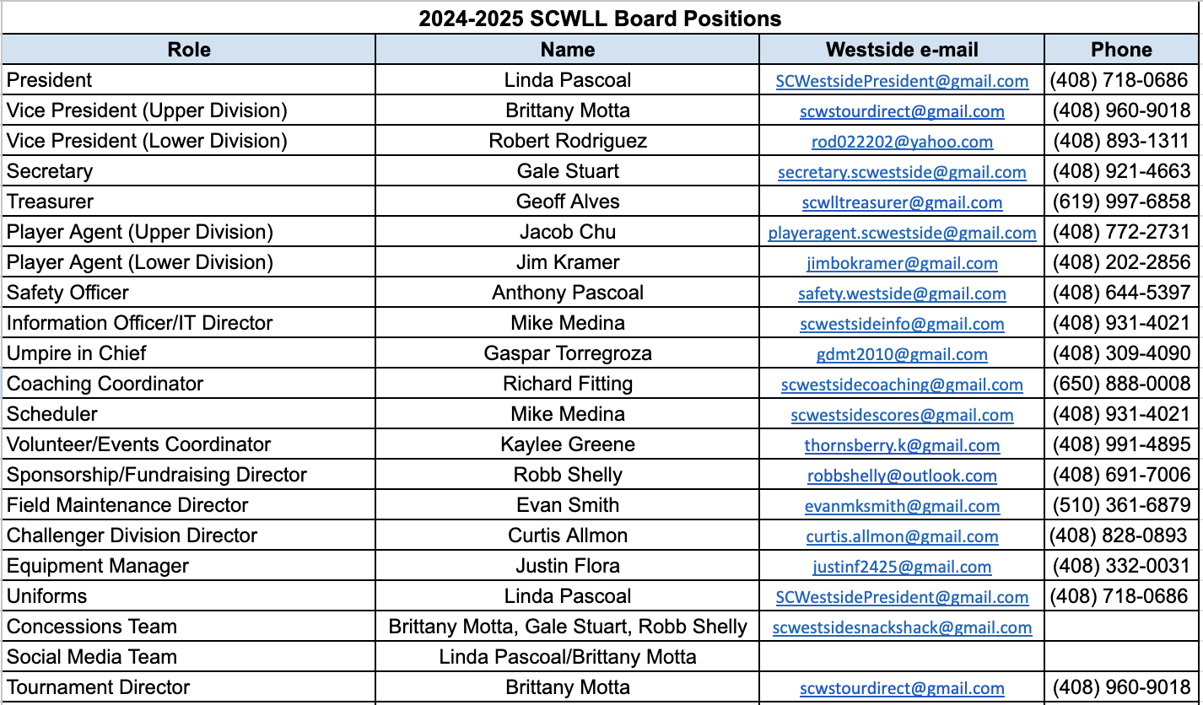

# Safety Roles & Responsibilities

Safety is not only the responsibility of the Safety Officer, but the responsibility of everyone who participates, in any manner, in Westside Little League.

## Safety Officer

The Westside LL Safety Officer shall be an officer and member of the Board. The Safety Officer has overall responsibility for safety issues, primarily building and ensuring compliance with this Safety Plan. They will make sure this Plan is made widely available to the League and submitted to Little League® International and to District 44.

The Safety Officer is available to the Westside LL community to address questions/concerns as it relates to safety and to report any injuries or instances of unsafe conditions. They can be reached at [safety.westside@gmail.com](mailto:safety@alpinelittleleague.com).

Specifically, the Safety Officer shall:

* Coordinate all safety activities; ensures safety in player training; ensures safe playing conditions; coordinates reporting and prevention of injuries; solicits suggestions for making conditions safer; and reports suggestions to Little League® International through the President.
* Coordinate with all the volunteers in Westside LL to provide the safest environment possible, and to rapidly resolve any unsafe conditions brought to his/her attention.
* Ensure an Injury Log is maintained. This log will list where and when accidents and injuries occurred, to whom, in which divisions, and who was under what supervision at the time of the injury.
* Work with the Player Agent, Coaching Coordinator and Umpire Coordinator to provide a Safety and First Aid Clinic for all managers, coaches, and umpires during the pre-season.
* Ensure all Medical Releases and Concussion Awareness forms are executed by players and parents (via the online registration system) before a player may attend practice or games with Westside LL.

## Board President

Ultimately the safety policies of the League rest with the President. The President shall maintain an active Safety Officer as a Board member of the League. They shall ensure all coaches, managers and Board members have completed a formal background check and fingerprinting in accordance with Little League and California law requirements. At each Board meeting, the President shall ensure that any safety issues, updates, or concerns are addressed in a timely manner. Finally, the President shall report to the Board on attendance at the first aid/safety clinics and compliance with the background check requirements, making sure the Board is aware of any issues.

## Equipment Manager

The Westside LL Equipment Manager has safety responsibilities, primarily the inspection, distribution and maintenance of equipment including first aid kits. The Equipment Manager shall:

* Inspect all baseball equipment for safety prior to the start of the season.
* Ensure a safety inventory is completed for all teams so that unsafe equipment can be discarded and replaced with new equipment.
* Provide a fully equipped first aid kit that can be replenished as needed. First aid kits are kept in the equipment bags issued to each team, so they are available at each game.
* Report to the board at the end of each season on the equipment needed for the following season to provide safe equipment.

## Fields Maintenance Director

The Fields Maintenance Manager’s primary responsibility is ensuring safe and playable fields for the League. The Fields Maintenance Manager shall:

* In coordination with the safety officer, conduct a safety audit of every playing facility used by teams prior to each season.
* Post emergency and league official numbers at each field.
* Ensures basic First Aid procedures are posted at each field.
* Ensures safety procedures are posted for the concession stand and provides instructions for each volunteer.

## Managers/Coaches

Managers and coaches bear the primary responsibility for ensuring the safety of players during practices and games. Managers and coaches must meet specified fundamentals and

first-aid/safety training requirements, which are specified in this Plan.

Ultimately the Manager is responsible for the safety of his/her players AND ultimately responsible for the actions of his/her designated coaches. If a Manager leaves the field or is unavailable, that Manager shall designate a Coach as a substitute and such Substitute Manager shall have the duties, rights and responsibilities of the Manager.

Managers must:

* Read this Safety Manual and bring it and the First-Aid Kit supplied by Westside LL to each to all practice or games.
* Make sure that telephone access is available at all activities including practices.
* Attend a training session on safety, concussion/head injuries, injury prevention and First Aid given by Westside LL. A manager or coach from each team must attend annually.
* Attend the fundamentals training. A manager or coach from each team must attend annually.
* Teach players the fundamentals of the game while advocating safety, including but not limited to:
  + Safely handling a baseball bat (helmets required in the vicinity of hitting drills)
  + Fielding ground balls and fly balls
  + Throwing correctly and only to players expecting a throw
  + Warming up to avoid injury
  + Turning away properly from a pitch thrown at the player
  + Sliding correctly
  + Understand and manage to what the players are safely capable of
* Notify a parent/guardian and the Safety Officer ([safety.westside@gmail.com](mailto:safety.westside@gmail.com)) if a child sustains a serious injury or suspected concussion. He or she cannot return to practice unless they have a note from their doctor.
* Encourage players and volunteers to bring water bottles to practices and games. Also, strongly encourage parents that they bring sunscreen for themselves and their child.
* Verify that coaches and volunteers have submitted completed current year background checks through the Westside LL website and LiveScan fingerprint checks. Do not permit anyone to assist with practice or games or have substantial contact with Westside LL players who has not complied with this requirement.
* Prior to a game Managers will:
  + Work with the umpire to walk the field prior to the game for hazards. Look for rocks, glass, holes, etc. and correct if feasible. It is the coach/manager’s responsibility to assure the players’ safety during the game. If there is a facility issue, report to the Safety Officer at [safety.westside@gmail.com](mailto:safety.westside@gmail.com)
  + Work with the umpire to inspect the players’ equipment before use. If a player has unsafe equipment, it is recommended it be made unusable to stop the player from “saving” it from waste.
  + Ensure players warm up prior to the game, are ready to play, and are not injured or sick.
* During the game Managers will:
  + Make sure that players carry all gloves and other equipment off the field and to the dugout when their team is up at bat. No equipment shall be left lying on the field, either in fair or foul territory.
  + Keep players alert in the field and orderly in the dugout.
  + Make sure catchers are wearing the proper equipment including cup and mask with dangling throat-guard. Catchers must wear a catcher's mask/helmet during warmup and infield/outfield practice.
  + Always observe the “no on-deck” rule for batters and keep players behind the screens. Bats stay in bags or racks in the dugout.
  + Keep players off the fences, backstops, and cages.
  + Encourage players to drink often so they do not dehydrate, and to apply sunscreen.
* Never allow children to play if they are ill, sustained a suspected concussion or head injury, or are injured. In the event of a collision, play it safe and test for suspected concussion using tools provided in Heads Up Concussion training.
* Players in a cast may not enter a game.
* Immediately attend to players who become injured in a game. You must notify a parent no matter how small or insignificant the injury is. If there was an injury requiring professional medical care, notify the Westside LL Safety Officer.
* Supervise ejected, ill or injured players until released to the parent, guardian, or person the parent or guardian designates.
* Discuss any safety problems that occurred before, during, or after the game with the Westside LL Safety Officer.
* Ensure players use equipment appropriate and allowed for age, division, and ability. For example, do not use hardballs in divisions where safety balls are provided and mandated.

## Umpires

Umpires have primary responsibility for enforcing Little League rules, many of which are grounded in safety considerations, as well as concern for fair play. They also inspect helmets, catcher’s masks, bats, and the field looking for potential safety issues prior to each game.

The Umpire Coordinator shall:

* Make sure that each umpire is trained on safety aspects of play, including no head-first slides, no on–deck batter, and no unsafe equipment.
* Instruct umpires to check helmets, bats, and catcher’s gear prior to the start of each game to ensure compliance.
* Instruct umpires to take possession of any unsafe equipment and turn it in to the league’s Equipment Manager for replacement.
* Ensure umpires report any unsafe conditions to the Managers/Coaches participating at the facility and report to the League Safety Officer.
* Instruct umpires to report back on any instances of violations of safety rules during play and the Umpire Coordinator shall report those instances to the President.

## Parents

Parents should discuss basic safe practices with players, such as not swinging bats except in appropriate areas under appropriate supervision. Some of these basic tenets are discussed in the Westside LL Code of Conduct. Additionally, parents should set a good example for players.

## Players

Portions of this Westside LL Safety Code apply to the players. Players should review these portions of the Code – with a parent as applicable – and adhere to them.

# Emergency & Injury Notifications

## Emergency Notification Procedures

1. Dial **9-1-1**.
2. Give the dispatcher the necessary information. Clearly and calmly answer any questions the dispatcher asks. Most dispatchers will ask:
   1. The exact location or address of the emergency? Include the name of the facility, address and city, cross streets, landmarks (ex. closest field, snack shack, bathroom, playground, etc.), and any other details requested by the dispatcher. The addresses for our gameday fields are:
      1. Steve Carli Park, 1045 Los Padres Blvd, Santa Clara, CA 95050  
         Cross Streets: Benton Street/Arlene Street
      2. CW Haman Elementary School, 865 Los Padres Blvd, Santa Clara, CA 95050  
         Cross Street: Patricia Drive
      3. Earl R. Carmichael Park, 3445 Benton St, Santa Clara, CA 95051  
         Cross Street: Curtis Avenue
   2. The telephone number from which the call is being made.
   3. The caller’s name.
   4. What happened? Ex., baseball-related accident, collapse or loss of consciousness, stroke, bicycle or vehicle accident, fire, etc.?
   5. How many people are involved?
   6. The condition of the injured person? Ex., unconscious, severe bleeding, etc.?
   7. What help is being given? Ex., first-aid, CPR, etc.?
3. Do not hang up until the dispatcher tells you to hang up. The dispatcher may put you on hold while they dispatch first responders.
4. Continue to care for the injured party until first responders arrive, following the dispatcher’s instructions.
5. Appoint someone to go to the street and look for the first responders and flag them down. This can save valuable time. Remember, every minute counts.
6. Appoint someone to call the SCWLL President and Safety Officer as soon as possible. Important: If only one phone is available, stay on the line with the dispatcher until they tell you to hang up, then call the SCWLL President and Safety Officer as soon as possible.

## What to do if a Player is Injured

If a person is injured during a game, practice, or other league-approved activity:

* Administer First-Aid treatment if necessary or call 9-1-1 if necessary.
* If the injured party is a child, immediately contact their parent(s)/guardian(s) if they are not on site at the time of the incident.
* When an incident or injury (child) occurs which requires any medical treatment, managers shall immediately notify the injured child’s parent(s)/guardian(s), no matter how small or insignificant the injury may seem. There are no exceptions to this rule.
* Contact the league safety officer as soon as possible
* Document the incident with as much detail as possible using the [Incident/Injury Tracking Report](https://www.littleleague.org/downloads/incident-injury-tracking-form/) (more information below).
* If medical attention is needed, provide the family a copy of the [Accident Claim Form](https://www.littleleague.org/downloads/accident-claim-form/) and assist as-needed

### First Aid Guidance

Per Little League requirements based upon [California Health and Safety Code Section 124235](https://leginfo.legislature.ca.gov/faces/codes_displaySection.xhtml?sectionNum=124235.&lawCode=HSC), on an annual basis, SCWLL shall provide a concussion and head injury information sheet and sudden cardiac arrest information to each athlete. These topics are included in the following subsections.

### Cardiac Arrest – Immediately Call 911

Hands-Only CPR for adults who suddenly collapse, is CPR without mouth-to-mouth breaths. It is recommended for use by people who see an adult suddenly collapse in the “out-of-hospital” setting. It consists of two simple steps:

* Immediately call 9-1-1 (or send someone to do that).
* Begin providing high-quality chest compressions by pushing hard and fast in the center of the chest with minimal interruptions.

### Concussions & Head Injuries

A concussion is a traumatic brain injury that affects brain function. Effects are usually temporary but can include headaches and problems with concentration, memory, balance, and coordination. Concussions are usually caused by a blow to the head. They can be fatal if the proper precautions are not taken.

1. If an injured party is unconscious after a blow to the head, immediately call 9-1-1. Do not move them. See preceding section.
2. If an injured party received a blow to the head during a game or practice and is suspected of sustaining a concussion, they should be removed from play for at least the remainder of that day. **When in doubt, sit them out!**
3. If the injured party is a child, immediately notify the parent(s)/guardian(s).
4. If the injured party is not unconscious, note any symptoms and monitor for any significant changes within a short period of time. If symptoms significantly worsen, or if at any time you observe danger signs such as loss of consciousness, mismatched pupil sizes, vomiting or nausea, slurred speech, or seizures, call 9-1-1.
5. The injured party should seek immediate medical attention. If a player misses seven (7) or more continuous days of participation, a physician or other accredited medical provider must give written permission for a full return to baseball activity. The medical clearance should include instructions and a timeline for appropriate activities in which they can participate upon their return. A copy of the medical clearance must be provided to the league.

### Heat Illness

Exercise produces heat within the body and can increase an athlete’s body temperature. Add to this a hot or humid day and any barriers to heat loss such as padding and equipment, and the temperature of the individual can become dangerously high. If left untreated, the elevation of core body temperature can cause organ systems to shut down in the body.

If you observe or experience symptoms of heat-related illness, stop that person’s activities and require them to take a break to cool off in the shade and hydrate. Continue to observe the person for more serious signs and symptoms that may indicate heat stroke. If necessary, call 9-1-1.

If one person is exhibiting symptoms of heat-related illness, others may be too, or they may be close to it, so stop all activities to provide a break for everyone. During extreme weather events, SCWLL may cancel or postpone games and/or practices (see inclement weather policy, Section 9). The CDC offers the following [guidance](https://www.cdc.gov/heat-health/risk-factors/heat-and-athletes.html?CDC_AA_refVal=https%3A%2F%2Fwww.cdc.gov%2Fextreme-heat%2Frisk-factors%2Fextreme-heat-and-athletes.html).

### Dental Injuries

If a tooth is knocked out, dislocated, or broken, gently rinse the tooth and mouth with water to try to remove any debris, then place a sterile dressing directly on the tooth and/or gums, and tell the victim to gently bite down on the dressing as much as comfortable to stabilize the injury. If a tooth or a portion of a tooth is knocked out and unable to be temporarily reimplanted, wrap the tooth in saline-soaked gauze by only touching the enamel, not the root. If a child is injured, immediately notify the child’s parents.

Advise the injured party or their parents to seek immediate medical attention and/or contact their dentist. Dentists have a higher chance of repairing a tooth if they can do so quickly and if the tooth has been properly cared for.

### Bloodborne Pathogens

There is a potential risk that bloodborne pathogens can be transmitted when an injured party is bleeding. Please consider the following guidance.

* If safe, the bleeding person should be removed from the field as soon as possible.
* Athletes, managers, coaches, umpires, and other volunteers with open wounds should refrain from all direct contact with others until the condition is resolved. Bleeding must be stopped, the open wound covered, and clothing changed if there is blood on it before returning.
* Latex or nitrile gloves can help reduce exposure when contact with blood or other bodily fluids is anticipated. Gloves should be included in each First-Aid kit.
* If possible, wash your hands before and after giving care, even if you wear gloves.
* Immediately wash hands and other skin surfaces if contaminated with blood after assisting an injured party.

If you think you have put yourself at risk, get tested. A blood test will determine whether or not your body is producing antibodies in response to a bloodborne pathogen. If you are not sure whether you should be tested, call your doctor.

### COVID – 19

This Safety Plan attempts to identify and adhere to all state and county health orders, guidance, and directives regarding COVID-19, and this Safety Plan will be updated as guidance changes; however, due to the complexity and evolving nature of the state and county requirements, this Safety Plan may be out-of-date as the season progresses. For the most up-to-date state and county requirements, please visit their websites.

SCWLL will adhere to the County’s [COVID-19 Guidelines for the General Public](https://publichealth.santaclaracounty.gov/diseases/covid). If you have tested positive for COVID-19 or are experiencing symptoms, follow the County's guidelines.

All players, coaches and volunteers shall stay home if they are diagnosed with COVID-19 and notify the safety officer if other league personnel have potentially been exposed.

## Injury Reporting

Once the immediate needs of the injured person have been addressed, Westside LL instructs all managers/coaches to report incidences of injury to the Safety Officer as soon as possible after they occur.

The League Safety Officer will maintain a database of all reporting injuries. This allows the Safety Officer to reach out to the parents about the injury, to implement any policy changes that may be necessary to prevent future similar injuries or address any ongoing training or other injury prevention measures.

### What to Report?

Any incident that causes any player, manager, coach, umpire, or volunteer to receive medical treatment and/or first aid must be reported to the Safety Officer. The terms "medical treatment and/or first aid" include any injury that (a) causes a player to miss any practice or game time; or

(b) any event that has the potential to require the medical assistance of a physician for evaluation and diagnosis must be reported promptly. X-rays are a diagnostic tool, so only positive x-rays will require follow-up and medical clearance to return.

Any injury - no matter how minor - should be reported to the player’s parent or guardian as soon as practicable (at the end of practice/game, later that day by phone or email, etc.)

If the injured party misses seven (7) or more continuous days of full participation due to a medical condition, a physician or other accredited medical provider must give written permission for a full return to baseball activity.

### Incident/Injury Tracking Report

When an incident or injury (child) occurs which requires any medical treatment, managers shall immediately notify the injured child’s parent(s)/guardian(s), no matter how small or insignificant the injury may seem. There are no exceptions to this rule.

When an incident or injury (child or adult) occurs which requires medical treatment beyond basic First-Aid, managers shall notify the SCWLL President or Safety Officer via telephone as soon as possible but no more than 4 hours after the incident or injury. There are no exceptions to this rule. The manager is then required to submit an [Incident/Injury Tracking Report](https://www.littleleague.org/downloads/incident-injury-tracking-form/) to the Safety Officer within 24 hours. The form can be downloaded and completed electronically and then emailed to the Safety Officer (preferred) or print and fill-out a hard copy and arrange for delivery.

Managers are also encouraged to submit an [Incident/Injury Tracking Report](https://www.littleleague.org/downloads/incident-injury-tracking-form/) for “near misses” as a proactive tool to evaluate safety practices and identify areas for improvement. Near misses can help identify and resolve potential issues before they lead to an actual incident or injury. Please clearly indicate “NEAR MISS” on the top of the form.

The League Safety Officer will receive this injury report and will enter it into the League's injury database. Within 48 hours of receiving the incident report, the Safety Officer will contact the injured party or the party's parents and (1) verify the information received; (2) obtain any other information deemed necessary; and (3) check on the status of the injured party.

If the extent of the injuries are more than minor in nature, the Safety Officer may periodically call the injured party to check on the status of any injuries and to check if any other assistance is necessary such as submission of insurance forms, the medical release form, etc. or until such time as the incident is considered "closed" (i.e. no further claims are expected and/or the individual is participating in the league again).

### Accident Claim Form

The SCWLL President will advise the parent(s)/guardian(s) of the league’s insurance coverage and the provision for submitting any claims and will assist the injured party or their parent(s)/guardian(s), if needed, to complete an [Accident Claim Form](https://www.littleleague.org/downloads/accident-claim-form/), which shall be submitted to Little League Headquarters within 20 days of the incident.  Please review the [Accident Claim Form Instructions](https://www.littleleague.org/downloads/accident-claim-form-instructions/) for assistance.

When an incident or injury (child) occurs which requires any medical treatment, managers shall immediately notify the injured child’s parent(s)/guardian(s), no matter how small or insignificant the injury may seem. There are no exceptions to this rule.

### Return to Play

During games, if an athlete is injured and removed from the game, a team manager is not permitted to return the injured athlete to the game without first having a medical professional at the game site clear the player. If the player receives medical clearance to return to the game after being removed due to injury, they are required to complete mandatory play, if applicable.

If the injured party receives a medical restriction from a physician and/or if the injured party misses seven (7) or more continuous days of full participation, a physician or other accredited medical provider must give written permission for a full return to baseball activity.

Under no circumstances is a player allowed to return to play without being cleared and able to fully participate and complete mandatory play (i.e. offense and defense)

The medical clearance should include instructions and a timeline for appropriate activities in which they can participate upon their return. A copy of the medical clearance must be provided to the league. Please also refer to: [How to Handle an Injured Player, Returning to Play After Injury](https://www.littleleague.org/university/articles/how-to-handle-an-injured-player-returning-to-play-after-injury/)

# Player Evaluations and Team Placement Safety

Westside LL welcomes all children to play baseball and wants to create as welcoming and safe an environment as possible. At times it is necessary to consider certain safety concerns (either for the player him/herself or for his/her teammates) related to a player’s skill level or ability. These concerns may be raised during player evaluations or may not become apparent until after the player has been placed on a team during the season.

When it becomes apparent at player evaluations that a player may need to play in a lower or higher division than his/her league age alone might suggest, the Player Agent will reach out to the player’s family for a conversation. Together they will make the division assignment that is best for the player’s safety and that of his/her future teammates.

There may also be times when it becomes apparent after the season begins, that for safety reasons, a player either needs to move down or up a division or some special protections need to be put in place on his/her current team to keep everyone safe. In this case, the manager shall raise these concerns to the Player Agent. The Player Agent, the manager and the player’s family shall meet to discuss the best course of action to keep everyone safe and create the best learning and playing environment for everyone.

## 2025 Little League Age Chart

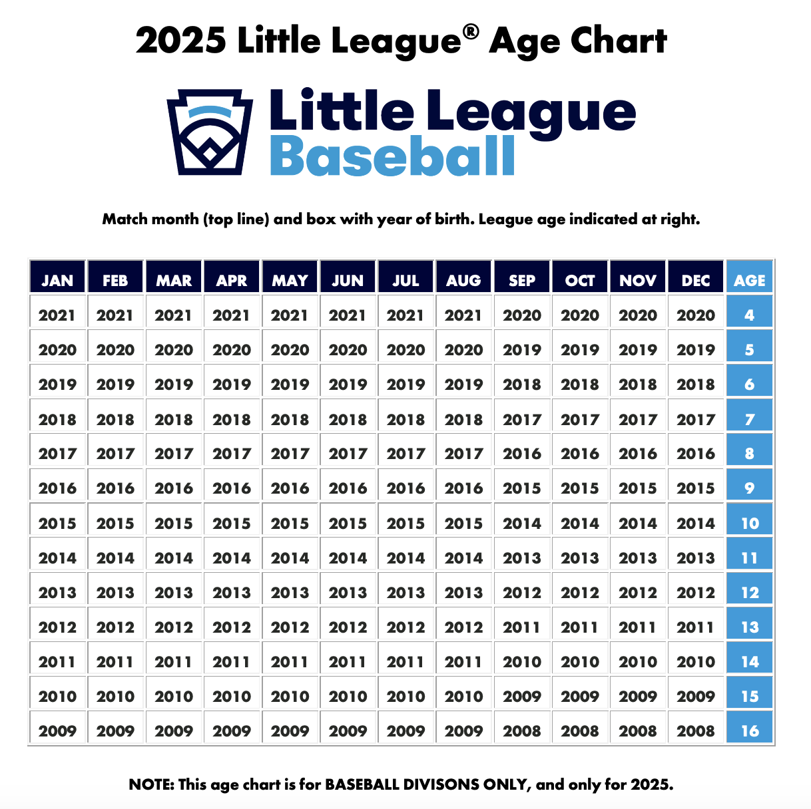

## Guidelines for Division Placement

Players normally play two seasons in each division. We encourage players to move up in divisions if they have the experience.  
  
League age 7-12 year old’s should attend player evaluations so managers, coaches, and board members can assess each player's experience and skill level before teams are drafted. This helps the league to establish the player pool and appropriate number of teams for each division, and to place each player in the appropriate division for their development.

**Note:** Players can be moved down or moved up a division after Player Evaluations. Refer to the introduction of section 4 for more information.  
By Division

* **Tee Ball Division (League age 4-5 year olds):** No previous/very minimal prior baseball experience. Kids hit off a tee.
* **Rookie Division (League age 5-7 year olds):** Minimal baseball experience. Coach pitch.
* **Farm Division (League age 7-9 year olds):** Minimal or some experience. Farm is a developmental division/a child who falls in this age range.
* **Minors Division (League age 8-10 year olds):** Has experience/a child who falls in this age range.
* **Majors Division (League age 10-12 year olds):** Has experience/a child who falls in this age range.
* **Challenger Division:**Little League baseball's adaptive program for players with physical or intellectual challenges.

By Age

**Age - Division of Play**

* **4-6** - All 4-5 year olds and most 6 year olds play T-Ball/Rookie
* **7**  - Most 7 year olds play Farm. Players with little to no experience also play rookie.
* **8**   - Most 8 year olds play Farm. A few skilled 8 year olds may play up to Minor.
* **9**   - Most 9 year olds play Minor. Players with little to no experience also play Farm.
* **10 -** Most 10 year olds play Minor. A few skilled 10 year olds may play up to Major.
* **11** - Most 11 year olds play Major. Players with little to no experience also play Minor.
* **12 -** All 12 year olds play in the Major Division. A 12 year old will only play in the Minors if the player is deemed a safety risk, requires a parent signature and approval from the board.

***Player ages are guidelines and are not absolutes***

## Special Physical Conditions

Parents/guardians of players with special conditions or needs must ensure that the team’s manager/coaches are aware of any such conditions or needs. SCWLL provides a registration form permitting you to describe any conditions or needs of which the manager/coaches for your child’s team should be aware.

# Volunteer Screening & Compliance

## Little League Volunteer Application & Background Check

Pursuant to Little League Regulation I(b) and I(c) 8 & 9, all Westside LL Board Members, Coaches, Managers, Adult Umpires, and other volunteers who regularly come in contact with children are required to complete volunteer registration/application and a background check annually through our Westside LL website. This includes concession stand volunteers and team parents.

Our website uses Little League International’s preferred background check provider, JDP. The JDP background check provides a nationwide criminal search, national sex offender registry search, and review of the US Center for SafeSport’s Centralized Database & Little League Ineligible List. As mandated by Little League International, Westside LL will not permit any person to participate in the League, whose background check reveals a conviction or guilty plea for any crime involving or against a minor.

Background checks are required prior to the volunteer assuming his/her duties for the current season. Failure to complete a background check as required by the League and upon request makes that adult ineligible to volunteer in any capacity with Westside LL. Information provided or revealed during a background check may be securely stored by Westside LL for all personnel named above, for a minimum of the duration of the applicant’s service to the league.

Westside LL will maintain the privacy of these records, and will use them only for the intended purpose, i.e., to perform the mandatory background check. Westside LL will prohibit any individual from participating as a volunteer or hired worker if the league deems the individual unfit to work with minors.

Westside LL will consider the following criteria, amongst other considerations, when evaluating potential volunteers:

1. Any background check that reveals a conviction for, guilty plea, no contest plea, or admission to any crime involving or against a minor must result in immediate termination from the league.
2. Felony convictions within the past 10 years and misdemeanors within the past 5 years are subject to disqualification as a volunteer.

For more information on Little League’s Child Protection Program and conducting background checks, go to: [What You Need to Know About the Little League® Volunteer Application Process](https://www.littleleague.org/university/articles/what-you-need-to-know-about-the-little-league-volunteer-application-process/).

*Important reminder: The Little League background check requirement does not replace the Live Scan requirement described in Section 6.2, or vice versa. They are separate requirements.*

### Background check (JDP) process for volunteers

All volunteers must register on the SCWLL [website](https://clubs.bluesombrero.com/Default.aspx?tabid=1231052), which now incorporates the volunteer application and background check. All Little League volunteer positions are annual positions, and need to be reapproved, pending a background check, each year. Anyone refusing to fill out or withhold/falsify information on a volunteer application and complete a background check are ineligible to volunteer.

## Fingerprint Background Check Requirement (LiveScan)

Pursuant to California Assembly Bill No. 506, effective January 1, 2022, in addition to the JDP background check of national databases described above, Westside LL must also conduct a one-time finger-print based background check of the California Department of Justice database using Live Scan. As such, all Westside LL Board Members, managers, coaches, adult umpires, and volunteers who have repetitive access to players will be required to obtain a LiveScan background check in addition to completing the JDP background check in 5.1 above.

Like the JDP background checks above, the League President will review the results of all volunteer LiveScan reports and will not permit someone to serve based on results that would deem the individual unfit to work with minors.

### Child Protection Program and Mandated Reporters

As provided in the “Protecting Young Victims from Sexual Abuse and Safe Sport Act of 2017,” all Westside LL volunteers who interact with children are considered mandated reporters and must report suspected child abuse, including sexual abuse, within 24 hours to law enforcement. California Assembly Bill No 506 further emphasizes this requirement and requires the presence of at least two mandated reporters when interacting with children.

#### Mandated Reporting within 24 hours

Westside LL has a zero-tolerance culture that does not allow any type of activity that promotes or allows any form of misconduct or abuse (mental, physical, emotional, or sexual) between players, coaches, parents/guardians/caretakers, spectators, volunteers, and/or any other individual. Coaches/Managers/Umpires must remove any individual that is exhibiting any type of mental, physical, emotional, or sexual misconduct and report the individual to the authorities immediately, but in no event more than 24 hoursafter becoming aware of the misconduct or abuse.

#### No Retaliation

Further, Westside LL and Little League International have a policy that prohibits retaliation against “good faith” reports of child abuse. Potential reporters should not be afraid to come forward in cases where they either have firsthand knowledge of or a good faith belief that abuse has occurred, even if there is a possibility that the report is wrong.

#### Limited One on One Contact

Westside LL asks coaches and managers to schedule practices and games when more than one League approved volunteer can be present. Westside LL’s policy is to limit one-on-one contact with minor participants when the interaction is not in an observable and interruptible distance from another adult. Minor participants must always be supervised by appointed volunteers and/or hired workers who have completed the mandated background check process.

### LiveScan Process for Volunteers

Volunteers are required to go through this process for each league, school, and/or other non-profit they volunteer for; therefore, it is strictly prohibited to share the fingerprint background check results with other local Little Leagues, schools, or other non-profits.

Process for volunteers:

1. Request SCWLL’s “ORI” number from the Safety Officer.
2. Volunteers must use the correct “ORI” code for SCWLL.
3. Complete form *8016 - Request for Live Scan Service*s either online or bring the completed form with you to the Live Scan location.
4. Westside LL is contracting with the Postal Annex, located next to Target at 2010 El Camino Real, Santa Clara, CA 95050

Westside LL will cover the costs (approximately $75) for LiveScan for our volunteers.

*Important reminder: The Live Scan requirement does not replace the Little League background check requirement described in Section 5.1, or vice versa. They are separate requirements.*

## Mandated Notice of Background Check Process per California Law

As a California youth athletic program, we are required to provide notice that all Westside Little League volunteers in regular service to the League or with repetitive access to children, including all managers/coaches, are required to complete a state and federal criminal background check. We will make sure to provide this notice on our website.

Additional information about Little League’s Child Protection Program can be found [here](https://www.littleleague.org/player-safety/child-protection-program/).

# Safety Training

Training is open to all volunteers. Some of the below training is required for all coaching staff while others require just one coach that will be present at every practice and game per team; however, all coaches are welcome at all the training. For example, the manager of a team can do all the training, or one coach from a team can do all the training, or the manager and coaches of a team can each do different training to satisfy this requirement.

Exceptions to this are the Abuse Awareness Training and Diamond Leadership training, which shall be completed by every board member, manager, and coach (not just one person per team). Westside LL will facilitate the required training sessions for the following topics, which may be completed internally or may be completed through a third-party provider:

Required for all Volunteers/Managers/Coaches annually:

1. Abuse Awareness Training

Required for all Managers/coaches one time:

1. Concussion Safety
2. Diamond Leadership Training

Required for at least one manager/coach per team annually:

1. Managers Meeting
   1. Safety Plan
   2. SCWLL bylaws and local rules
2. First-Aid, cardiopulmonary resuscitation (CPR), automated external defibrillator (AED)
3. District 44 Rules Clinic
4. Baseball Fundamentals (required for all tournament managers and coaches, recommended for all)
5. Positive Coaching Alliance (TBD)

Please submit copies of your certifications to the league Safety Officer to this [google form.](https://docs.google.com/forms/d/1pmqdaSuMIbvw2wFbNyWcubE0zbgcU1oZ1YA91QNdDp8/edit)

## Managers Meetings

The Safety Officer, along with each Division Director and/or UIC will meet with managers to discuss the Safety Plan, SCWLL bylaws and local rules updates, and general expectations prior to the first practice (approximately 1 hour).

## CPR/AED/First Aid Training

At least one manager/coach per team is required to have current CPR/AED/First-Aid training. SCWLL will schedule CPR/AED/First-Aid training, if needed, for managers and/or coaches to comply with this requirement. If at least one manager/coach per team already has current, American Heart Association (AHA)-certified CPR/AED/First-Aid training that will not expire before the end of the current season, additional training is not required.

Following selection of team managers, the Safety Officer will evaluate whether CPR/AED/First-Aid training needs to be scheduled. CPR/AED/First-Aid training must be completed prior to the start of the regular season (approximately 1.5 hours).

CPR/AED/First-Aid training will be provided by SCWLL prior to the 2025 spring season.

## Concussion Safety

The Centers for Disease Control and Prevention (CDC) provides online concussion safety training with their [HEADS UP to Youth Sports: Online Training](https://www.cdc.gov/headsup/youthsports/training/index.html) (approximately 1 hour). Per Little League requirements based upon [California Health and Safety Code Section 124235](https://leginfo.legislature.ca.gov/faces/codes_displaySection.xhtml?sectionNum=124235.&lawCode=HSC), each manager, coach, and administrator (not just one person per team) must complete concussion training at least once before supervising a SCWLL athlete in a league activity.

Please click [here](https://www.littleleague.org/player-safety/concussions-youth-athletes/) for more information about the Little League and California Health and Safety Code requirements. This training is also available to athletes, parents/guardians, sports officials, athletic trainers, and other individuals interested in learning about concussion safety. Individuals can register and complete the training on their own through the CDC website using the link above. The CDC HEADS UP training must be completed prior to the start of the regular season. This is a one-time training and may be carried over each year.

## Diamond Leadership Training

Focused on ensuring children have a positive, well-rounded experience on and off the field, the [Little League® Diamond Leader Training Program](https://www.littleleague.org/diamondleader/) is a free educational resource that provides coaches with an understanding of the impact that mental, social, and emotional well-being has in youth sports through detailed information, interactive scenarios, and a variety of additional resources.

Through this course, which navigates Little League volunteers through real-life scenarios that are being faced in local leagues all around the world each year, coaches will have a better understanding of the impact they have on their players, both on and off the field.

## Abuse Awareness Training

In 2018, the “Protecting Young Victims from Sexual Abuse and SafeSport Authorization Act of 2017” became Federal law. All athletes deserve to participate in sports free from bullying, hazing, sexual misconduct, or any form of emotional or physical abuse. Education and awareness are the most critical components to creating safe and respectful sporting environments, free of abuse and harassment.

There are certain requirements from the SafeSport Act that Little League International and all local little league programs must adhere to:

1. Reporting of abuse involving a minor to the proper authorities.
   1. All volunteers of a local league are **mandated reporters** and could face criminal charges if the abuse is not reported to the proper authorities, any witnessed act of child abuse, including sexual abuse, within 24 hours.
   2. Please visit [LittleLeague.org/ChildAbuse](http://littleleague.org/ChildAbuse) for additional information regarding proper procedures to report sexual abuse in California.
2. SCWLL prohibits retaliation on “good faith” reports of child abuse.
3. Adults shall not have private, secluded, or otherwise obscure, one-on-one contact with minors, including electronically. The Abuse Awareness training provides examples of appropriate and prohibited one-on-one interactions.
4. Complete the Abuse Awareness training provided by USA Baseball and SafeSport.

[Abuse Awareness](https://www.littleleague.org/university/articles/abuse-awareness-training-course/) shall be completed by every board member, manager, and coach (not just one person per team) prior to the start of the regular season. The Abuse Awareness for Adults course is FREE and provides resources to create a positive and safe environment for all athletes, coaches, parents, umpires, and spectators by understanding how to recognize misconduct and abuse of all types. Topics covered include how to identify and report incidents and what abuse awareness policies should be in place (approximately 1 hour). This is a one-time training and may be carried over each year.

## District 44 Rules Clinic

In addition to the SCWLL bylaws and local rules discussed in the managers meeting, District 44 is providing a Little League rules clinic for umpires, managers, coaches, and parents. At least one manager/coach per team is required (Farm Division and above; approximately 3 hours).

The recorded videos from the District 44 Rules Clinic will also be available on YouTube:

[https://www.youtube.com/watch?v=oHIYhRD3_IU](https://youtube.com/channel/UCPIq8EZA94FSYf1i3CW-00ghttps://www.youtube.com/watch?v=oHIYhRD3_IU) (or search "D44 Rules Clinic").

## Baseball Fundamentals

Baseball fundamentals training generally qualifies a volunteer for 3 years.

The [USA Baseball Coaches Certification Program](https://usabdevelops.com/USAB/Certification/Coach_Certification.aspxq) is a certification pathway for any and all individuals who are currently coaching baseball or aspire to coach at any level of the game. The program aims to create a higher standard of coaching education and enhance the ability of coaches to better serve their athletes, their team, and their communities. USA Baseball has also established [Virtual Community Clinics](https://usabdevelops.com/USAB/Certification/Virtual_Clinics/USAB/Certification/Virtual_Community_Clinics.aspx?hkey=4d97f426-fe27-407a-835c-dd088b7f5c27) that will take the place of in-person Community Clinics that are part of the USA Baseball Coaches Certification Pathway. The user account and the courses are *FREE*. At least one manager/coach per team is recommended to complete the training.

Little League University also offers a variety of resources for parents, coaches, umpires, and league officials at [www.littleleague.org/university](http://www.littleleague.org/university). The [Little League Diamond Leader Training Program](https://www.littleleague.org/diamondleader/) is focused on ensuring children have a positive, well-rounded experience on and off the field, this program is a *FREE* educational resource that provides coaches with an understanding of the impact that mental, social, and emotional well-being has in youth sports through detailed information, interactive scenarios, and a variety of additional resources. The Little League Diamond Leader Training Program is recommended for all regular season managers and coaches.

SCWLL has a Coaching Coordinator assigned for the 2024 season. The Coaching Coordinator may augment, enhance, or substitute the baseball fundamentals training as needed.

## Umpire Training Clinic

The Westside LL Umpire in Chief arranges a required, in-depth training for our adult and youth umpires. These trainings include detailed review of game rules as well as all safety procedures including (i) instructing umpires to check helmets, bats, and catcher’s gear prior to the start of each game to ensure compliance, (ii) instructing umpires to take possession of any unsafe equipment and turn it into the Equipment Manager for replacement, (iii) mandated reporter requirements discussed above and (iv) concussion and sudden cardiac arrest prevention.

It is recommended and encouraged that at least one manager or coach from each team (Farm Division and above) attend a clinic session.

## Positive Coaching Alliance

SCWLL may arrange for managers and/or coaches to complete the [Positive Coaching Alliance (PCA) Little League Double-Goal Coach® online training](https://www.littleleague.org/partnerships/pca/). SCWLL will provide additional information regarding PCA online training when available.

PCA’s Mission: “*Be a catalyst for a positive youth sports culture in all communities across the U.S.*”

PCA’s Vision: “*PCA believes that all youth can benefit from a positive, inclusive sports culture that develops social and emotional skills, molds character, and prepares them for competition and life. Encouraging athletes with positive reinforcement helps them hear and heed the necessary corrections. With that winning combination of truthful, specific praise and constructive criticism, athletic performance improves and so do the chances that kids stick with sports longer and learn all the valuable life lessons inherently available through organized competition.*”

## Training Requirements Guide

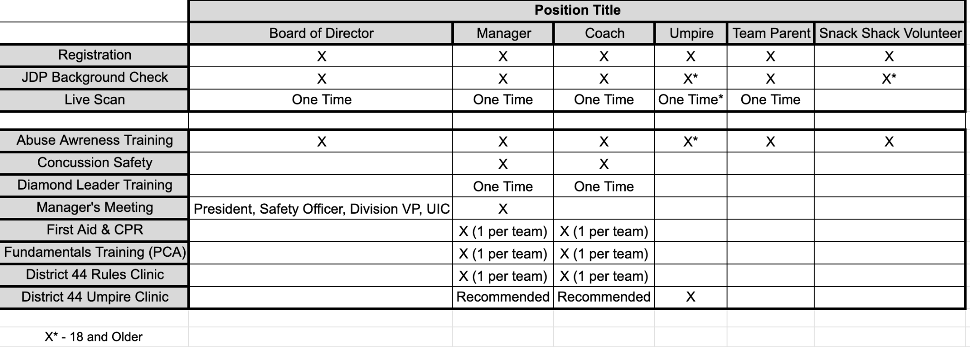

## Credentialing

Effective Spring 2024, all managers and coaches will be given credentials identifying that they have completed their background check, live scan, and required training (Sections 5 & 6). Managers and coaches **must wear their credentials for games**.  Coaches that do not have their required credentials will not be able to coach on the field during practices and games, including warmups.

Coaches and managers will be identified by yellow lanyards. Board members will be identified by blue lanyards.

## Submitting Training Documentation

All training can be submitted using the following [google form](https://docs.google.com/forms/d/e/1FAIpQLSfwXfrJifspXZd4pEOr8yqJjIpU4HZQ3EfYsoTQXs8KdT_jQg/viewform?usp=header) which is also available on the Santa Clara Westside LL Website. If there are any issues with the form, training documentation can be sent to the Westside LL Safety Officer via email to [safety.westside@gmail.com](mailto:safety.westside@gmail.com).

# Fields & Facility Safety

## Field & Facility Access

Safety and security of all Westside facilities will be taken seriously. Use of the fields and/or facilities shall be at the discretion and permission of the board.

Only board members and managers are to be issued keys to fields and facilities. Managers will only be given keys that are applicable to their field and batting cage use. All keys are to be returned at the end of the season.

Westside LL works closely with the City and Santa Clara and the Santa Clara Unified School District on the maintenance, use, safety, and security of their fields. Please report any issues or suggestions to the Westside LL board.

## Field Inspections

The Fields Maintenance Manager and/or the Safety Officer will conduct a safety audit of every playing facility used by teams prior to the start of each season. They will also ensure that basic first aid procedures are posted at each field.

Further, coaches and managers are required to inspect the field for safe playing conditions before each game and practice. Umpires are required to report any unsafe conditions to the managers/coaches participating at the facility and report to the Safety Officer at [safety.westside@gmail.com](mailto:safety.westside@gmail.com).

Westside LL will complete our annual Little League Facility Survey with the submission of our Safety Plan.

## Guidelines for the use of Batting Cages

Westside LL has implemented the following guidelines for use of batting cages:

* Adult supervision is required at all times.
* Close the entry gate prior to batting.
* Batters must wear helmets.
* Pitcher/pitching machine operators must use an “L” screen.
* Only coaches may pitch to batters. No 'kid pitchers' allowed, including “soft toss”.
* Pitching machines must be operated by an adult.
* Only batter and one pitcher/machine operator allowed during batting.

Westside LL must give the user permission prior to use of the batting cage. Batting cages will not be used for personal gain, financially or otherwise by any member of Westside LL.

## Maintenance and Equipment Shed Safety

All individuals with keys and/or combinations for the locks to the SCWLL maintenance and equipment sheds (i.e., managers, coaches, umpires, volunteers, etc.) must be aware of their responsibilities for the orderly and safe storage of equipment. Under no circumstances will copies of keys and/or combinations to the batting cages and/or storage sheds be given to any child or to any person who is not authorized to use them.

Anyone who desires to use any of the machinery located in the sheds (i.e., lawn mowers, weed whackers, lights, scoreboards, public address systems, etc.), must request and receive the proper training by a member of the field maintenance committee. Individuals are prohibited from operating any machinery on the complex without the express consent of the field maintenance committee and only after having received the proper training.

All chemicals or organic materials within SCWLL sheds must be stored in their appropriate containers with proper labeling as to their contents and potential hazards.

All chemicals or organic materials within SCWLL sheds must be stored in a manner as to minimize the risk of puncturing the containers.

Any witnessed “loose” chemicals or organic materials within SCWLL sheds must be cleaned up and properly disposed of immediately.

## Concession Stand (Snack Shack) Safety

The following guidance must be reviewed and followed by all SCWLL snack shack workers.

### Concession Stand Inspection Checklist

The following list is adapted from Little League’s [*Concession Stand Inspection Checklist*](https://www.littleleague.org/university/articles/concession-stand-inspection-checklist/) and must be reviewed and completed prior to reopening the snack shacks each season.

* Cooking Appliances and Equipment - The snack shack has a variety of appliances and equipment for cooking. Make sure that cooking appliances are in good working order.
* Electrical Outlets and Sinks - Prior to beginning operation each season, inspect and test every electrical outlet, sink, and faucet in the snack shack to make sure they are working properly.
* Countertops, Tables, and Floors - Food and debris left over from the previous season or the previous game can be the source of serious health concerns if it attracts insects and rodents. Inspect these areas carefully and discard any food damaged by pests. Any pesticides shall not be used near food and shall be stored away from any food.
* Training - One of the best ways to avoid injuries and incidents in the snack shack is by properly training the workers. This includes giving clear guidelines on operating equipment and creating a safe working environment. The following sections provide relevant information and guidelines regarding snack shack safety that must be followed.
* Bring in the Pros - If necessary, it may be a good idea to enlist the help of a local restaurant manager to come in and take a look to ensure you haven’t missed anything with your safety inspection. It is also recommended to consult the local and/or state health inspection office.

### Food Safety

During warm weather, it is especially important to take extra precautions and practice safe food handling when preparing perishable foods such as meat, poultry, seafood and egg products.

The warmer weather conditions may be ideal for outdoor picnics and barbecues, but they also provide a perfect environment for bacteria and other pathogens in food to multiply rapidly and cause foodborne illness.

Follow the suggestions below to Fight BAC!® (foodborne bacteria) and reduce the risk of foodborne illness this summer.

[Seven Super Steps to Safe Food](https://cpd.sccgov.org/food-safety) (from the County of Santa Clara):

* Wash, Wash, Wash Your Hands. Always wash your hands with warm water and soap for at least 20 seconds before and after handling food. Sing Row, Row, Row Your Boat twice to get a sense of how long you should wash.
* Marinating Mandate. Always marinate food in the refrigerator. Don’t use sauce that was used to marinate raw meat or poultry on cooked food. Reserve a portion of the unused marinade to use as a sauce.
* Hot, Hot, Hot. When grilling foods, preheat the coals on your grill for 20 to 30 minutes, or until the coals are lightly coated with ash.
* Temperature Gauge. Use a food thermometer to ensure that food reaches a safe internal temperature.
* Where's the Beef? Chicken and Fish? Hamburgers should be cooked to 160 ºF, while large cuts of beef such as roasts and steaks may be cooked to 145 ºF for medium rare or to 160 ºF for medium. Poultry must reach a temperature of 165 °F. Fish should be opaque and flake easily.
* Stay Away from that Same Old Plate. When taking foods off the grill, do not put cooked food items back on the same plate that held raw food, unless it has been washed with hot water and soap first. And in hot weather (above 90°F) foods should never sit out for more than one hour before going in the refrigerator.
* Icebox Etiquette. A full cooler will maintain its cold temperatures longer than one that is partially filled so it is important to pack plenty of extra ice or freezer packs to ensure a constant cold temperature. Keep the cooler out of the direct sun. Keep drinks in a separate cooler from foods. The beverage cooler will be opened frequently while the food cooler stays cold.

### Food Safety Certification

At least one SCWLL board member or designated volunteer must be always certified in food safety. Additionally, both SCWLL concession stands must pass health and safety inspections by Santa Clara County Public Health before any food or beverage is sold each year. A Santa Clara County Health Permit will be posted.

### General Concession Stand Safety

The following list is adapted from Little League’s [*Concession Stand Safety Tips: 12 Steps to Safe, Sanitary Food Service*](https://www.littleleague.org/university/articles/concession-stand-safety-tips-12-steps-to-safe-sanitary-food-service/), and is intended to help develop a healthy and safe work environment for SCWLL’s snack shacks. Following these simple safety tips will help minimize the risk of foodborne illness and limit the chance of injury.

1. Simple Menu - Keep your menu simple, and keep potentially hazardous foods (meat, eggs, dairy products, protein salads, cut fruits and vegetables, etc.) to a minimum. Avoid using precooked foods or leftovers. Use only foods from approved sources, avoiding foods that have been prepared at home. Having complete control over your food, from source to service, is the key to safe, sanitary food service.
2. Food Thermometer - Use a food thermometer to check on cooking and holding temperatures of potentially hazardous foods. All potentially hazardous foods should be kept at 41⁰ F or below (if cold) or 140⁰ F or above (if hot). Most foodborne illness from temporary events can be traced back to lapses in temperature control.
3. Cooling and Cold Storage - Foods that require refrigeration must be cooled to 41⁰ F as quickly as possible and help at that temperature until ready to serve. Allowing hazardous foods to remain unrefrigerated for too long has been the number ONE cause of foodborne illness.
4. Hand Washing - Frequent and thorough hand washing remains the first line of defense in preventing foodborne disease. The use of disposable gloves can provide an additional barrier to contamination, but they are no substitutes for hand washing!
5. Health and Hygiene - Only healthy workers should prepare and serve food. Anyone who shows symptoms of disease (cramps, nausea, fever, vomiting, diarrhea, jaundice, etc.) or who has open sores or infected cuts on the hands should not be allowed in the food concession area. Workers should wear clean outer garments and shall not smoke in the concession area. The use of hair restraints is recommended to prevent hair ending up in food products.
6. Food Handling - Avoid hand contact with raw, ready-to-eat foods and food contact surfaces. Use an acceptable dispensing utensil to serve food. Touching food with bare hands can transfer germs to food.
7. Washing Dishware - Use disposable utensils for food service. Keep your hands away from food contact surfaces, and never reuse disposable dishware. Wash in a four-step process: Washing in hot soapy water; Rinsing in clean water; Chemical or heat sanitizing; and Air drying
8. Ice - Ice used to cool cans/bottles should not be used in cup beverages and should be stored separately. Use a scoop to dispense ice; never use the hands. Ice can become contaminated with bacteria and viruses and cause foodborne illness.
9. Wiping Cloths - Rinse and store your wiping cloths in a bucket of sanitizer (example: 1 gallon of water and ½ teaspoon of chlorine bleach). Change the solution every two hours. Well sanitized work surfaces prevent cross-contamination and discourage flies.
10. Insect Control and Waste - Keep foods covered to protect them from insects. Store pesticides away from foods. Place garbage and paper wastes in a refuse container with a tight-fitting lid. Dispose of wastewater in an approved method (do not dump it outside). All water used should be potable water from an approved source.
11. Food Storage and Cleanliness - Keep foods stored off the floor at least six (6) inches. After your event is finished, clean the concession area and discard unusable food.
12. Minimum Worker Age - The minimum age to work in the snack shack is thirteen (13); however, at least one adult shall also be present.
13. Dress Code - Workers must be appropriately dressed without offensive words or images on their clothing. Closed-toe shoes must be worn.
14. Volunteer Registration and Background Check Requirements – See Section 6
15. Buddy System - Closers should not be left alone, especially at night. At least one other snack shack worker or a manager, coach, or other volunteer should remain with the closer and leave together.

### Additional Concession Stand Safety Resources

* [California Retail Food Code](https://www.cdph.ca.gov/Programs/CEH/DFDCS/CDPH%20Document%20Library/FDB/FoodSafetyProgram/MEHKO/CALIFORNIA%20RETAIL%20FOOD%20CODE%202019.pdf)
* County of Santa Clara [Food Safety Program](https://cpd.sccgov.org/programs-and-services/food-safety-program)
* County of Santa Clara [Food Safety Certification](https://cpd.sccgov.org/food-safety-certification)
* County of Santa Clara [Food Safety Handouts](https://cpd.sccgov.org/food-safety-handouts)

# Equipment & Player Safety

## Equipment Inspection & Replacement

The Equipment Manager inspects all used baseball equipment for safety prior to the start of the season. Unsafe equipment can be discarded and replaced with new equipment. The Equipment Manager will also report to the Board at the end of each season as to the equipment needs for the following season to provide safe equipment.

The Equipment Manager shall inspect all assigned equipment to ensure it is safe and in good working order and that it complies with equipment standards (ex. [bats](https://www.littleleague.org/university/articles/playing-equipment-inspection-baseball-softball-bats/) and [batting helmets and catcher’s gear](https://www.littleleague.org/university/articles/playing-equipment-inspection-batting-helmets-and-catchers-gear/)). Equipment that does not meet specifications must be removed from the inventory. All equipment and storage sheds shall be inspected to comply with Section 7.4.

### Required Equipment

All catchers are required to wear the full gear at all practices and games. This includes warming up the pitchers. All players must wear a helmet during batting and running the bases and while coaching first or third base.

### Bats

Westside LL may or may not distribute bats. Managers and umpires are responsible for monitoring the compliance of all bats brought by individual players to ensure they meet Little League International rules.

All baseball bats to be used in the Major Division and below, must be affixed with the [USABat Standard](https://www.littleleague.org/playing-rules/bat-information/) marking, and deemed to be in accordance with Little League Rule 1.10 as outlined in the current edition of the Little League Rules, Regulations, and Policies. In Little League Baseball Intermediate 50/70, Junior, and Senior Divisions BBCOR bats are permitted. In each instance, all bats that may be used in the ensuing game must be void of any physical damage, or an altered state, that would prevent the bat from complying with the USABat Standard.

## Manager’s & Umpire’s Responsibilities

### Prior to Each Practice

Each Manager shall:

* Confirm the athletes are healthy and alert.
* Ensure athletes returning from injury have a medical release form signed by their doctor; otherwise, they can’t play.
* Ensure athletes are wearing proper attire and that male catchers are wearing a cup.
* Inspect all equipment to ensure it is safe and in good working order and that it complies with equipment standards (ex. [bats](https://www.littleleague.org/university/articles/playing-equipment-inspection-baseball-softball-bats/) and [batting helmets and catcher’s gear](https://www.littleleague.org/university/articles/playing-equipment-inspection-batting-helmets-and-catchers-gear/)). Equipment that does not meet specifications must be removed from the field.
* Make sure telephone access is available. It is suggested that a cellular phone always be on hand.
* Evaluate whether unsafe weather conditions exist or are forecast or if unfit field conditions exist. See inclement weather guidance in Section 9.
* Walk the field to check the field is free of hazards and obstructions (ex. holes, rocks, and glass) before use and immediately eliminate any hazards. Report all major hazards that need additional resources to the President and Safety Officer.

### Prior to Each Game

Each manager shall:

* Complete all requirements listed in Section 5 & 7.
* Agree with the opposing manager on the fitness of the playing field. If the two managers cannot agree, the umpire in chief (i.e., home plate umpire for the game), the SCWLL President, or a duly delegated SCWLL representative shall make a final determination to proceed with or postpone the game.

The umpire in chief (i.e., home plate umpire for the game) shall:

* Ensure athletes are wearing proper attire and that male catchers are wearing a cup.
* Inspect all equipment to ensure it is safe and in good working order and that it complies with equipment standards (ex. [bats](https://www.littleleague.org/university/articles/playing-equipment-inspection-baseball-softball-bats/) and [batting helmets and catcher’s gear](https://www.littleleague.org/university/articles/playing-equipment-inspection-batting-helmets-and-catchers-gear/)). Equipment that does not meet specifications must be removed from the field.
* Walk the field to check the field is free of hazards and obstructions (ex. holes, rocks, and glass) before use and immediately eliminate any hazards. Report all major hazards that need additional resources to the President and Safety Officer.
* Ensure that all playing lines are marked with non-caustic lime, chalk, or other white material easily distinguishable from the ground or grass.
* Secure official Little League baseballs for play from each team or the office/snack shack.
* Ensure catchers wear a catcher’s helmet/mask and catcher’s glove when warming up pitchers.
* Act as the sole judge as to whether and when play shall begin if unsafe weather conditions (ex. rain, lightning, fog, darkness, etc.) exist or are forecast or if unfit field conditions exist. See inclement weather guidance in Section 9.0.

### During Each Game

Each manager shall:

* Remove equipment damaged during the game.
* Ensure that athletes carry all gloves and other equipment off the field and to the dugout following their defensive half-inning. No equipment shall be left on the field.
* Confirm the athletes remain healthy and alert.
* Keep athletes off the field unless they are participating in the game (i.e., assigned a defensive position or at-bat) or retrieving a bat between batters. No “on-deck” warmups.
* Ensure no players are throwing balls or handling bats in the dugouts at any time.
* Keep athletes off fences and keep athletes from hanging from the roof of the dugouts.
* Remind athletes to drink water often to avoid dehydration.
* Remove injured athletes from play until properly evaluated and treated. Athletes shall not return to play if a concussion is suspected.
* Remove themself, coaches, or athletes if they begin to experience symptoms that may be indicative of COVID-19.
* Disinfect catcher’s gear between players.

The umpire in chief (i.e., home plate umpire for the game) shall:

* Govern the game as mandated by Little League Rules and Regulations.
* Remove baseballs deemed unfit for use.
* Ensure catchers are wearing the proper equipment.
* Continue to monitor the field for safety and playability.
* Keep athletes off the field unless they are participating in the game (i.e., assigned a defensive position or at-bat) or retrieving a bat between batters. No “on-deck” warmups.
* Ensure no players are throwing balls or handling bats in the dugouts at any time.
* Keep athletes off fences and keep athletes from hanging from the roof of the dugouts.
* Act as the sole judge as to whether and when play shall be suspended or cancelled due to unsafe weather conditions (ex. rain, lightning, fog, darkness, etc.) or if unfit field conditions exist; and as to whether and when play shall resume after a game is suspended. See inclement weather guidance in Section 12.2.
* Remove themself if they begin to experience symptoms that may be indicative of COVID-19.

### Following Each Game

Each manager shall:

* Clean and tidy their dugout and shared equipment (ex., rakes, field daggers, field striping equipment, etc.).
* Return the field to its pre-game condition.
* Report any field or equipment issues that were discovered before, during, or after the game to the equipment manager via both telephone and email.

The umpire in chief (i.e., home plate umpire for the game) shall:

* Clean and tidy any shared umpire equipment that was used.
* Discuss potential safety violations or concerns with each manager.
* Report any field or equipment issues that were discovered before, during, or after the game to the equipment manager via both telephone and email.

## First Aid Kits

All teams receive a fully equipped first aid kit including ice packs that can be replenished as needed by the Equipment Manager. First aid kits are kept in the equipment bags issued to each team, so they are available at each game. Coaches and managers are also instructed to have the kit available at all practices and games.

Additional large first aid kits are located at the following locations:

* Steve Carli (Westside) concession stand.
* Earl Carmichael (Homestead) concession stand.
* Steve Carli Farm Field Shed

## Automated External Defibrillator (AED) Machines

Automated External Defibrillators (AEDs) and CPR equipment for assistance during cardiac arrest events are in the following locations:

* Steve Carli (Westside) concession stand.
* Earl Carmichael (Homestead) concession stand.
* Steve Carli Farm Field Shed

## Fire Extinguishers

Fire extinguishers are located in the snack shack and in each scorekeeper’s booth at both Steve Carli and Earl R. Carmichael Parks, in the office at Steve Carli Park, in the storage area behind the bleachers at Steve Carli Park, and in the Farm field shed at CW Haman Elementary School.

# Inclement Weather & Environmental Factors

Most of our days in northern California are warm and sunny, but there are days when the weather can create unsafe playing conditions. The following guidance will assist managers, coaches, and umpires with evaluating whether to conduct practice or play a game.

During practice, the manager is responsible for evaluating whether unsafe weather conditions exist or are forecast or if unfit field conditions exist.

Prior to a game, the league (i.e., President with input from the managers and Division Directors) and the umpire in chief (i.e., home plate umpire for the game) may judge whether and when play shall begin if unsafe weather conditions exist or are forecast or if unfit field conditions exist prior to a game.

During a game, the umpire in chief is the sole judge as to whether and when play shall be suspended or canceled due to unsafe weather conditions or if unfit field conditions exist; and as to whether and when play shall resume after a game is suspended.

## Rain

* + - 1. Evaluate the strength of the rain.
         * Is it currently raining or is it forecast to rain?
         * Is it a light drizzle or is it pouring?
         * How long has it been raining, and how much longer is it expected to rain?
         * How much total precipitation is expected?
      2. Determine the direction the storm is moving.
      3. Does radar show only a slight break in the forecast, or will the storm completely pass?
      4. Is the rain reducing ball visibility or creating other on-field hazards (ex. slippery bases or balls)?
      5. Evaluate the playing field as it becomes more and more saturated. If you press your foot into the grass and it does not rebound or water accumulates in your footprint, the field is too saturated.
      6. In addition to player safety, we must also consider long-term field health.
         * *The City provided the following guidance for City-managed fields: “To preserve the life and conditions of the fields, users shall not play in wet conditions. A field is considered too wet if you can see standing water, hear a ‘squishy’ sound when walking on the turf, or have mud on the bottom of your shoes after walking on the turf. Play is allowed during a light mist if the ground is hard and relatively dry. If the field has been overwatered, or it has been raining for three days, or wet conditions exist as described above, groups are not to play.”*
         * *SCUSD provided the following guidance for SCUSD-managed fields: “The user is responsible for monitoring weather conditions and evaluating playing fields when there is a threat of rain, lightning, or dangerous conditions. The district shall cancel events if field or weather conditions could cause harm.”*

## Lightning

While rare, we can have thunderstorms. Managers/Coaches are instructed to check the weather forecast before leaving for a game or practice and watch for signs of an approaching storm. If a storm is imminent, outdoor activities should be postponed.

When lightning is seen/heard anywhere near the vicinity of the field, our managers/coaches and umpires are instructed to:

* Take caution when you hear thunder. If you hear thunder, you are close enough to get struck by lightning. During a game, the umpire will clear the field in the event of an approaching storm.
* Move to a safe environment immediately. Do not go under a tree or stay in the dugout. Stay away from metal backstop, fencing, bleachers (including dugouts).
* If lightning is occurring and there is not sturdy enough shelter nearby, get inside a hard-top automobile and keep the window up.
* Stay away from water, metal pipes, and telephone lines.
* Unplug appliances not necessary for obtaining weather information.

Wait for an official umpire decision on whether to continue the game or the manager’s determination whether it is safe to continue practice.

Little League International has provided the following guidance:

When should activities be stopped?

The sooner activities are stopped and people get to a safe place, the greater the level of safety. In general, a significant lightning threat extends outward from the base of a thunderstorm cloud about 6 to 10 miles. Therefore, people should move to a safe place when a thunderstorm is 6 to 10 miles away. Also, the plan’s guidelines should account for the time it will take for everyone to get to a safe place. Here are some criteria that could be used to halt activities.

If lightning is observed. The ability to see lightning varies depending on the time of day, weather conditions, and obstructions such as trees, mountains, etc. In clear air, and especially at night, lightning can be seen from storms more than 10 miles away provided that obstructions don’t limit the view of the thunderstorm.

If thunder is heard. Thunder can usually be heard from a distance of about 10 miles provided that there is no background noise. Traffic, wind, and precipitation may limit the ability to hear thunder less than 10 miles away. If you hear thunder, though, it’s a safe bet that the storm is within ten miles.

If the time between lightning and corresponding thunder is 30 seconds or less. This would indicate that the thunderstorm is 6 miles away or less. As with the previous two criteria, obstructions, weather, noise, and other factors may limit the ability to use this criterion. In addition, a designated person must diligently monitor any lightning. In addition to any of the above criteria, activities should be halted if the sky looks threatening. Thunderstorms can develop directly overhead and some storms may develop lightning just as they move into an area.

When should activities be resumed?

Because electrical charges can linger in clouds after a thunderstorm has passed, experts agree that people should wait at least 30 minutes after the storm before resuming activities.

## Hot Weather

To help prevent heat related illness, Westside LL is adopting a Heat Index based approach to suspending league activity during periods of excessive heat. In all cases, Managers should use their discretion and err on the side of caution if there is any question about safety.

Actual Temperature or Heat Index (whichever is greater) shall be used to determine thresholds for play. Heat Index shall be determined by [accuweather.com](https://www.accuweather.com/en/us/sunnyvale/94087/weather-forecast/331979) (ReelFeel temperature) or weather.com (Feels Like temperature) entering zip code 95050. During periods of increased heat, Managers should check the forecast and make a judgment to cancel practice ahead of time should the forecasted temperatures exceed the thresholds. If the forecast is below the threshold, managers should check temperatures closer to game/practice time to confirm it’s still OK to play.

During Spring Ball, Managers may propose to reschedule a canceled game, schedule permitting. During Fall Ball, canceled games will not be rescheduled due to the compressed schedule of the Fall Season.

| **Temperature / Heat Index** | **Precautions** |
| --- | --- |
| Under 95 degrees F | Kids should be well hydrated prior to game/practice.  Allow Frequent water/shade breaks during practice.  Monitor kids for signs of exhaustion or stress (see safety manual). |
| 95 - 99 degrees F | Same as above plus:  During Practice - Mandatory Water breaks every 20 minutes in shaded area.  During Games - encourage hydration in dugout while on offense.  Allow kids water when requested Recheck Heat Index at every water break, suspending practice if it exceeds 100 degrees F (Manager/Umpire check every 2 innings during games)  Consider alternate practice options, limiting practice duration, more off field drills in shaded areas.  Alert parents of the possibility of cutting practice short. |
| 100 degrees F or higher | Suspend practice/games.  If in progress, alert parents to pickup kids, keep team in shaded area until picked up. |

## Air Quality Policy

Air quality can fluctuate quickly. The air quality can be very different in certain locations. We ask our managers to check AQI via [purpleair.com](http://purpleair.com/) for the location closest to the practice/game that day. Our managers are instructed to cancel games/practices if AQI is around 150 or higher. If the AQI is 100-150, practices/games will be optional for players. If the AQI is less than 100 the practice/game will continue as scheduled.

Generally, we ask our managers to check the AQI at about 3 pm for weekday practices and 1-2 hours prior to weekend practices/games. They should provide parents an update via TeamSnap with instructions on how to proceed around that time.

We realize that a lower AQI could quickly change into a much higher number while the players are at the field. If parents would rather keep their child home and not take the risk, the coaches will fully support the parent’s decision. The AQI could also decrease significantly after a decision has been made, leaving parents wondering why we cancelled. We must inform both parents and coaches in advance to provide time for planning and driving.

## Earthquake

Most league activities will occur outdoors in open fields with minimal overhead hazards, but major earthquakes will still present safety risks and logistical challenges, so it is important for managers to discuss earthquake safety with their players and parents/guardians during one of the first practices.

If you are indoors, such as the office or score booth, DROP, COVER, and HOLD ON. If you are in the snack shack, immediately stop all cooking, turn off the BBQ if it’s in use, and then take cover. Protect yourself from falling objects and shattered glass. Avoid taking cover near windows, large mirrors, hanging objects, or heavy appliances.

If you are on the playing field, shout earthquake to get everyone’s attention and immediately stop play (make sure the ball is stopped). Exit the dugout and move away from areas such as next to buildings, fences, backstops, tall trees, and utility poles, if needed. If you are already in an open area where falling objects are unlikely to strike you, stay in place and take a knee.

1. Check yourself and others for injuries. Attend to others if needed and if safe.
2. If you smell or hear a gas leak, clear the area and call 9-1-1.
3. Check for damage on the field such as displaced soil, holes, and large cracks; and check the dugouts, fences, foul poles, and backstop, including the overhang. If any of the field infrastructure is damaged or questionable, cancel the practice or game and call parents/guardians to begin pickups.
4. Report all observed damage to the SCWLL President and Safety Officer immediately.
5. If it was a minor earthquake and everyone is safe and there’s no damage on the field, you can continue the practice/game, but be prepared for aftershocks.

# Social Media Safety

The goal of SCWLL social media accounts is to educate, inform, inspire, and connect with our community. We ask that other users treat each other with courtesy and respect at all times. Little League International also provides a policy for the [Creation and Maintenance of Social Networking Sites by Local Leagues](https://www.littleleague.org/playing-rules/position-policy-statements/creation-maintenance-social-networking-sites-local-leagues/).

## Official Westside LL Website & Social Media Accounts

* [www.scwestside.com](http://www.scwestside.com)
* [www.Instagram.com/scwestside](http://www.instagram.com/scwestside)
* [www.facebook.com/SCWLL](http://www.facebook.com/SCWLL)
* [www.twitter.com/SCWestsideLL](http://www.twitter.com/SCWestsideLL)

## Social Media Community Guidelines

We reserve the right to hide or delete any of the following types of content, and block users who share it:

* Messages and comments that are misleading or false; we do not support spreading misinformation
* Messages and comments posted by anonymous or robot accounts
* Deliberate provocation of other community members in the form of intentional trolling, troll baiting, or flaming
* Racist, hateful, sexist, homophobic, slanderous, insulting, or life-threatening messages and comments
* Messages and comments that contain name-calling, personal attacks, or defamatory statements
* Messages and comments containing serious, unproven, or inaccurate accusations against individuals or organizations
* Abusive, aggressive, coarse, explicit, vulgar, violent, obscene, or pornographic messages and comments
* Messages and comments that infringe on copyrights
* Messages and comments for advertising purposes, except for approved SCWLL sponsors
* Messages and comments that suggest or encourage illegal activity

Messages and comments to SCWLL social media posts are only monitored and moderated periodically. Messages and comments will be read and addressed as quickly as possible. If there is an urgent concern that requires immediate attention, please contact the SCWLL President or Safety Officer directly (contact info is provided in Section 1.1).

In addition, the following social media restrictions apply to all SCWLL staff. For additional information, please refer to the required training.

* Staff and minor athletes may not follow each other.
* Staff may not direct or private message minor athletes.
* Staff members may not “tag” minor athletes on any posts unless for the purpose of communicating important team information.

# Code of Conduct

Little League International and all its local leagues promote and expect good sportsmanship by all. We request your cooperation by supporting the participants and officials in a positive manner. SCWLL has implemented the following code of conduct to clarify expectations regarding proper roles and behavior at SCWLL. All participants are required to acknowledge that they have both read and understand this code of conduct at the time they accept their volunteer assignment or complete the online registration process.

Profanity, racial or ethnic comments, or other intimidating actions that are deemed inappropriate will not be tolerated. Any person guilty of improper conduct at any game, practice, or other league event will be asked to leave the premises and will be suspended from the following game. Repeat violations may result in a multiple-game suspension or result in the forfeiture of the privilege of attending all remaining games.

## Preamble

SCWLL believes that the essential elements of character-building and ethics in sports are embodied in the concept of sportsmanship and six core principles:

1. Trustworthiness
2. Respect
3. Responsibility
4. Fairness
5. Caring
6. Good Citizenship

SCWLL believes that the highest potential of sports is achieved when competition reflects these “six pillars of character.”

## Code of Conduct

As a board member, manager, coach, athlete, parent/guardian, umpire, and/or any other volunteer, I agree:

1. I will not force children to participate in Little League.
2. I will remember that children participate to have fun and that the game is for youth, not adults.
3. I will inform a league official of any physical disability or ailment that may affect the safety of children or the safety of others.
4. I will learn the rules of the game and the bylaws and local rules of SCWLL.
5. I (and my guests) will be a positive role model for athletes and encourage sportsmanship by showing respect and courtesy, and by demonstrating positive support for all athletes, managers, coaches, officials, and spectators at every game, practice, or other league event.
6. I (and my guests) will not engage in any kind of unsportsmanlike conduct with any official, manager, coach, athlete, parent/guardian, or other spectator such as booing and taunting; refusing to shake hands; or using profane language or gestures.
7. I will not encourage any behaviors or practices that would endanger the health and well-being of the athletes.
8. I will teach youth to play by the rules and to resolve conflicts without resorting to hostility or violence.
9. I will demand that athletes treat everyone with respect regardless of race, creed, color, sex, or ability.
10. I will teach my child that doing their best is more important than winning so that my child will never feel defeated by the outcome of a game or their performance.
11. I will praise all athletes for competing fairly and trying hard.
12. I will never ridicule or yell at my child or other participants for making a mistake or losing a competition.
13. I will emphasize skill development and sportsmanship and how they benefit athletes over winning. I will also de-emphasize games and competition in the lower age groups.
14. I will promote the emotional and physical well-being of the athletes ahead of any personal desire I may have for my athletes to win.
15. I will respect the umpires and their authority during games and will never question, discuss, or confront umpires, managers, or coaches. I will schedule a time to speak with a manager and/or coach at an agreed upon time and place, if needed.
16. I will demand a sports environment for my child that is free from drugs, tobacco, and alcohol, and I will refrain from their use at all league events.
17. I will refrain from coaching my child or other athletes during games and practices, unless I am one of the official coaches of the team.

# Enforce little league rules & Regulations

Westside LL encourages all managers/coaches to read and ask clarifying questions to ensure they have a solid understanding of the Little League Official Rules, as well as Westside Little League’s Local Rules/Bylaws. Both documents are made available to all managers/coaches on our league website and are emphasized in our manager/coach trainings.

# Appendix

## Quick Safety Checklist for Managers, Coaches & Umpires

### Safe Playing Areas

Regular safety inspections of all fields, (practice and game), structures, and dugouts, is the best way to eliminate conditions that cause accidents. Managers, coaches, and umpires should routinely check playing area for:

* + - * Holes, damage, rough or uneven spots, slippery areas, and long grass
      * Glass, rocks, animal feces and foreign objects
      * Damage to screens or fences, including holes, sharp edges, or loose edges Unsafe conditions around backstop, pitcher’s mound, or warning track
      * Proper attire by the catcher at all times, including in the bull pens and in between innings

### Safe Equipment

All equipment shall be inspected before each use. Regular safety inspection of equipment is essential. Managers, coaches, and umpires should:

* + - * Be sure all equipment is LL approved
      * Inspect all bats, helmets, and other equipment on a regular basis.
      * Dispose of unsafe equipment properly.
      * Keep loose equipment stored properly
      * Have all players remove all personal jewelry
      * Parents should be encouraged to provide safety glasses for players who wear glasses
      * Repair or replace defective equipment

### Safe Procedures

Managers and coaches must:

* + - * Have all players’ medical release forms with you at every practice and game
      * Have a first aid kit with you all practices and games
      * Have access to a telephone in case of emergencies
      * Know where the closest emergency shelter is in case of severe weather Ensure warm-up procedures have been completed by all players
      * Stress the importance of paying attention, no “horse playing allowed”
      * Instruct the players on proper fundamentals of the game to ensure safe participation
      * Each practice should have at least 2 coaches in case of an emergency and as required by California law

## Field Operations Plans

### Steve Carli Park – 1045 Los Padres Ave, Santa Clara, Ca 95050

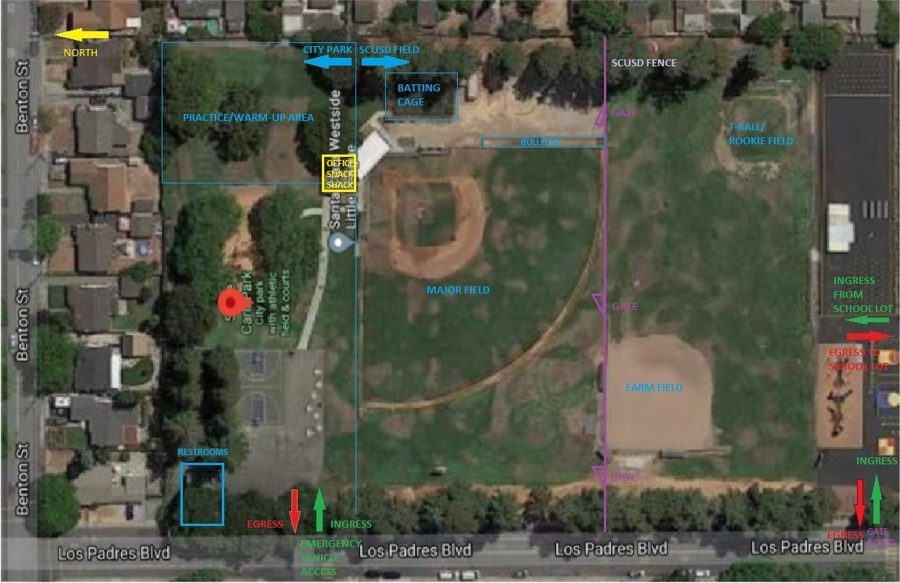

### Earl R. Carmichael Park – 3445 Benton St., Santa Clara, Ca 95050

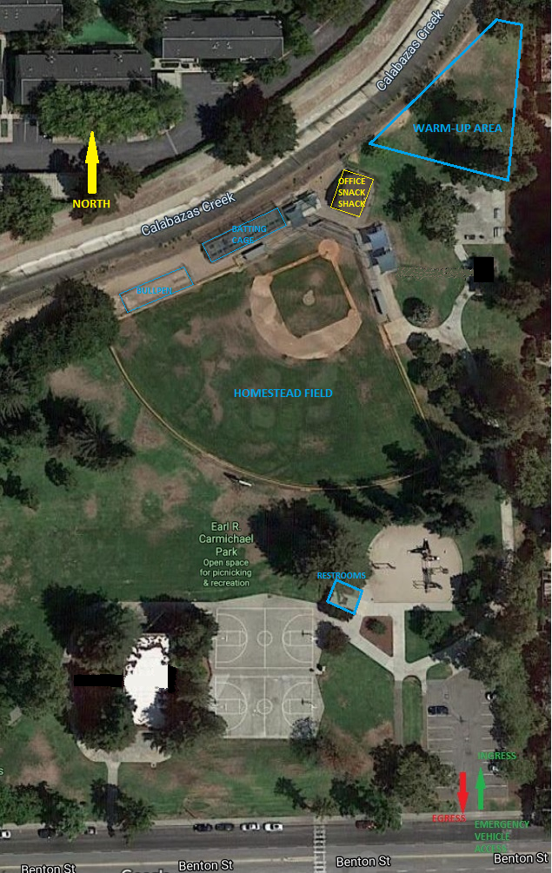

## Fact Sheets

### AHA Heart Attack Warning Signs

* + 1. **Concussion Fact Sheet**

### Heat Illness Fact Sheet

